# EE2004 Microcomputer System

# Mini-Project Title

|  |  |
| --- | --- |
| Team Member Name | ID: |
| TSOI Hing Chung Sunny | 55216557 |
| Tse Sin Man | 55231745 |

# Instructor: Leung Chi Sing Andrew

# Tutorial Session: TA4

# Tutorial Tutor: Chan Kwok Leung

# Semester B

# Date

24/4/2019

**Project Title: Digital Piano**

**Project Description**

It is to describe your project What it is supposed to do.

In this project, we have to design a digital piano with MPLAB and PIC18F4520 Microcontroller. The digital piano will produce 7 different sound (C, D, E, F…) and a melody (Little Star) by the buzzer when the 8 input buttons are pressed. Our digital piano system can also display the number of the button which is pressed by the user through 7 segment display. To generate different frequencies of the sound, we use time delay function and timer.

**System Architecture**

Draw the system architecture of your project and describe the functionality of each components

Hardware:

1. ND118-4520 development kit equipped with PIC18F4520 Microcontroller (fig. 1)

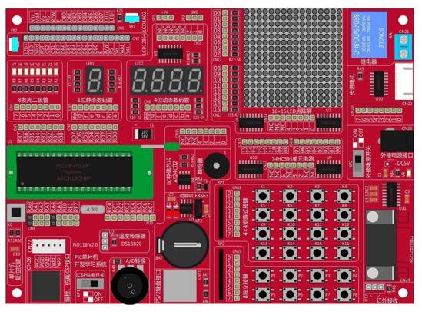

We used the following components:

* 8 input buttons (as input device)
* 1 7-seg display (as number output)
* Buzzer (as sound output)

1. Microchip’s PICkit3 In-Circuit Debugger/Programmer (fig. 2)

It is used to program the PIC18F4520 microcontroller

1. USB cables

Software:

1. MPLAB IDE V8

Connection:

**I/O Description**

It is to define the desirable input and output

In this section, the I/O description will be discussed. In our project, ND118-4520 development kit equipped with PIC18F4520 Microcontroller is used. There are lots of components in the microcontroller, but in the project only few components are used beside the PIC18F4520. There are 8-button, 7-segment LED display and buzzer.

For the input, the 8-button is used for distinguishing what button and the system can then be processing the corresponding function (seen figure 3).

For the output, there are mainly two components used which are 7-segment LED(seen figure 4) and buzzer(seen figure 5). The 7-segment LED is aimed to display different number due to different buttons are pressed. The buzzer is the most important component in this project since it is responsible for playing different tone.

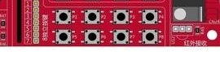

**fig 3**

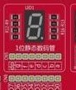

**fig 4**

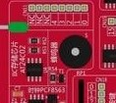

**fig 5**

**Program Description**

Description of your program structure with aid of flow chart if any

We discover that different sound can be played by modifying the frequency of the buzzer. Hence, we search the Internet and find 7 tonal scales with corresponding frequency. Table 1 illustrates the corresponding frequency of different sounds. We designed a delay function to generate a different frequency. We also designed a timer to generate a time delay. After that, the buzzer can play the sound according to the frequency created by the timer. After button 8 is pressed, the song “little star” will be played. Therefore, we created a subroutine “sound_of_song” which stores the corresponding values of different notes of “little star”. To avoid the speed of the song become too fast, we made another timer subroutine.

|  |  |  |  |  |  |  |  |
| --- | --- | --- | --- | --- | --- | --- | --- |
| Button | 1 | 2 | 3 | 4 | 5 | 6 | 7 |
| Pitch | C5 | D5 | E5 | F5 | G5 | A5 | B5 |
| Frequency(Hz) | 523.25 | 587.33 | 659.25 | 698.46 | 783.99 | 880.00 | 987.77 |

Table 1: the corresponding frequency of different sounds

Structure of our code:

First and foremost, the code will go to the Main to set and initialize the input and output ports. In the program, there are nine variables are used in subroutine which are DELAY_H, DELAY_L, input, led, con_long, con_loop, con_tone, con_song and con_stop. DELAY_H and DELAY_L are used in the main program for detecting whether the button is pressed or not. input shows which button is pressed and will be used in the subroutine later on. led is used to control the display on 7-segment LED. The rest of the variables are used in the subroutine as loop control variable.

Then the program will go to the loop part, which will keep scanning key. In the looping part, it will keep on scanning key. If the button (1 to 6) is pressed, the corresponding 7-seg display is turned on by file register “led”. After that, the program will jump to the ‘sound’ routine. This routine uses a delay function to implement sound output. If the button 8 is pressed, the program will jump to the “sound_of_timer” routine. This routine uses a timer to implement sound output. If the button 7 is pressed, the program will jump to “sound_of_song” subroutine.

In the later paragraph, each of the subroutine will be explained their operating principles. There are total three function to generate sound or melody through buzzer, two delay functions and one supporting subroutine “find_low”.

First of all, the “sound” subroutine is a function that would generate 6 different tone for corresponding buttons. There is a variable con_long is used. con_long is the loop control variable which not only allow the loop to process and also control how long will the tone last. According to pseudo code below, the value of con_long is set to 40h. This value had been tested and the tone outputted can have the best with con_long’ s value of 40H. After setting up the value for the loop control variable, bit 5 of PORTB is set to 1 to turn on buzzer and it will be set to 0 after the delay subroutine “delay_buzzer” is call.”find_low” is aimed to provide different delay time for each button. Thus it would check input before setting the value of con_tone.

After processing the delay function twice, the con_loop will be decreased by 1 and con_loop will be checked whether it is 0 or not. If not, the loop is continuous. Else the loop is broke, the subroutine is finished and return to the main function.

Pseudo code of “sound”:

set value of con_long to 40h

there turn on the buzzer (PORTB, 2)

call delay

toggle PORTB, 5 to create square wave

call delay

decrease con_long (create a loop)

check if con_long is zero or not if not keep loop, else return

Pseudo code of “delay_buzzer”:

set value of con_loop as 04h

call find_low and set con_tone

decreased con_loop by 1

check whether con_loop is 0 or not

if so end of loop and return, else continous

Pseudo code of “find_low”:

check input for detecting which button is pressed

put the corresponding value in WREG and return

Second, the “sound_of_timer” is similar with the “sound”. These two subroutines are playing different sound by generating square wave through buzzer. However, “sound_of_timer” does not need to call another delay function. It used the timer to generating square wave. While the timer is still counting, the buzzer is being toggle and a square wave will be generated.

pseudo code of “sound_of_timer”:

set 1 to PORTB,5 (turn on buzzer)

set up the timer

initialize the timer

setting up the value for TMR0H and TMR0L

toggle PORTB, 5 (generating square wave)

start turn on the timer

time_back

check whether the timer is finish

if so, turn on timer and return

else continuous and back the time_back

Finally, the “sound_of_song” is aimed to play a song through buzzer. In the beginning, our group wanted to use array to implement a song. However, with the limitation of time and programming skills. We do not implement song with array instead the tone is set inside “sound_of_song”. Then, “sound” is called to play the tone. In order to create a beat, there is another delay subroutine “delay_song” is used. This delay function would generate a fixed value of delay which allow the song is easier to recognize with a timer interrupt.

Pseudo code of “sound_of_song”:

set value of input with corresponding value

call sound

call delay_song

until the end of the song

Pseudo code of “delay_song”:

set con_stop as 40H

set con_song as ffh <-(stop)

set up timer interrupt

initialize the timer <-( again)

turn on timer

check whether is stopped or not

if so, decf con_song and if con_stop not equal to 0 bra again

else if con_stop equal to 0, con_stop decf

if con_stop = 0, return

else bra stop

Flow Chart:

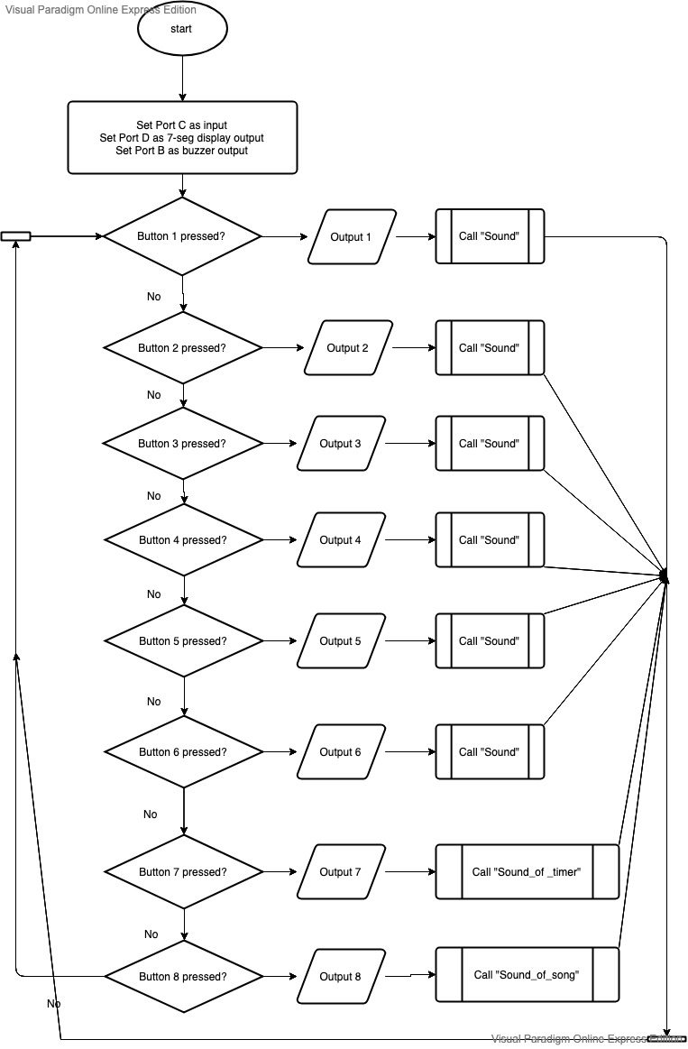

**Appendix**

Source Code

LIST P=18F4520

#include <P18F4520.INC>

CONFIG OSC = XT

CONFIG WDT = OFF

CONFIG LVP =OFF

CBLOCK 0X000

DELAY_H

DELAY_L

input

led

con_long

con_loop

con_tone

con_song

con_stop

ENDC

org 0x0000

goto main

org 0x0100

main: movlw 0x00

movwf input

clrf TRISD

clrf PORTD

bcf TRISB,2

bcf PORTB,2

setf TRISC

SETF PORTC

;P8 係第一粒

call display

Loop call read_press

call display_1

goto Loop

display: movlw d'0'

movwf input

movwf PORTD

return

display_1: movff led, PORTD

return

read_press:

wait_press: movf PORTC, w

xorlw 0xff

BNZ next_1

bra wait_press

next_1: btfsc PORTC, 0 ;user timer to generate delay

bra next_2

movlw b'11111110'

movwf input

movlw b'01111111'

movwf led

call sound_of_timer

bra exit

next_2: btfsc PORTC, 1

bra next_3

movlw b'11111101'

movwf input

movlw b'00000111'

movwf led

call sound_of_song

bra exit

next_3: btfsc PORTC, 2

bra next_4

movlw b'11111011'

movwf input

movlw b'01111101'

movwf led

call sound

bra exit

next_4: btfsc PORTC, 3

bra next_5

movlw b'11110111'

movwf input

movlw b'01101101'

movwf led

call sound

bra exit

next_5: btfsc PORTC, 4

bra next_6

movlw b'11101111'

movwf input

movlw b'01100110'

movwf led

call sound

bra exit

next_6: btfsc PORTC, 5

bra next_7

movlw b'11011111'

movwf input

movlw b'01001111'

movwf led

call sound

bra exit

next_7: btfsc PORTC, 6

bra next_8

movlw b'10111111'

movwf input

movlw b'01011011'

movwf led

call sound

bra exit

next_8: movlw b'01111111'

movwf input

movlw b'00000110'

movwf led

call sound

;call sound_of_song

exit: call delay

wait_up: movf PORTC

xorlw 0xff

BNZ wait_up

call delay

return

delay: MOVLW 0X7F

MOVWF DELAY_H

LOP_1: MOVLW 0

MOVWF DELAY_L

LOP_2: DECF DELAY_L,F

BNZ LOP_2

DECF DELAY_H,F

BNZ LOP_1

return

sound: movlw 0x40

movwf con_long

there bsf PORTB,2

call delay_buzzer

bcf PORTB,2

call delay_buzzer

decf con_long

bnz there

return

delay_buzzer:

movlw 0x04

movwf con_loop

a1 call find_low

movwf con_tone

hj decf con_tone

bnz hj

decf con_loop

bnz a1

return

find_low:

btfss input, 0

retlw 0x2a

btfss input, 1

retlw 0x3a

btfss input, 2

retlw 0x4a

btfss input, 3

retlw 0x5a

btfss input, 4

retlw 0x6a

btfss input,5

retlw 0x7a

btfss input, 6

retlw 0x8a

btfss input, 7

retlw 0x9a

sound_of_timer:

bsf PORTB,2

movlw 0x08

movwf T0CON

BCF INTCON, TMR0IF

movlw 0x01

movlw TMR0H

movlw 0x00

movlw TMR0L

BTG PORTB,2

start bsf T0CON,TMR0ON

time_back

BTFSS INTCON, TMR0IF

bra time_back

BCF T0CON, TMR0ON

bcf PORTB,2

return

sound_of_song:

movlw b'01111111' ;1

movwf input

call sound

call delay_song

movlw b'01111111' ;1

movwf input

call sound

call delay_song

movlw b'11110111' ;5

movwf input

call sound

call delay_song

movlw b'11110111' ;5

movwf input

call sound

call delay_song

movlw b'11111011' ;6

movwf input

call sound

call delay_song

movlw b'11111011' ;6

movwf input

call sound

call delay_song

movlw b'11011111' ;5

movwf input

call sound

call delay_song

call delay_song

movlw b'11101111' ;4

movwf input

call sound

call delay_song

movlw b'11101111' ;4

movwf input

call sound

call delay_song

movlw b'11011111' ;3

movwf input

call sound

call delay_song

movlw b'11011111' ;3

movwf input

call sound

call delay_song

movlw b'10111111' ;2

movwf input

call sound

call delay_song

movlw b'10111111' ;2

movwf input

call sound

call delay_song

movlw b'01111111' ;1

movwf input

call sound

return

delay_song:

movlw 0x40

movwf con_stop

stop movlw 0xff

movwf con_song

movlw 0x30

movwf T1CON

song_again

movlw 0xff

movwf TMR1H

MOVLW 0XFF

MOVWF TMR1L

BSF T1CON, TMR1ON

song_here

btfss PIR1, TMR1IF

BRA song_here

BCF T1CON, TMR1ON

decf con_song

bnz song_again

decf con_stop

bnz stop

return

END